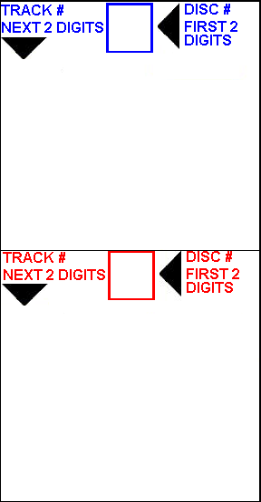

10. Track 10

11. Track 11

12. Track 12

13. Track 13

14. Track 14

15. Track 15

16. Track 16

17. Track 17

18. Track 18

**Title**

1. Track 1

2. Track 2

3. Track 3

4. Track 4

5. Track 5

6. Track 6

7. Track 7

8. Track 8

9. Track 9

10. Track 10

11. Track 11

12. Track 12

13. Track 13

14. Track 14

15. Track 15

16. Track 16

17. Track 17

18. Track 18

**Title**

1. Track 1

2. Track 2

3. Track 3

4. Track 4

5. Track 5

6. Track 6

7. Track 7

8. Track 8

9. Track 9

**02**

**01**